**PITUITARITY/ Adrenal**

**Opening question**

**“What is the Pituitary gland?”**

It is a protrusion of the hypothalamus at the base of the brain.

is a pea-sized gland that sits in the [sella turcica](https://en.wikipedia.org/wiki/Sella_turcica).

covered by a [dural](https://en.wikipedia.org/wiki/Dura_mater) fold ([diaphragma sellae](https://en.wikipedia.org/wiki/Diaphragma_sellae))

Weighs 0.5 g

composed of 2 lobes: [anterior](https://en.wikipedia.org/wiki/Anterior_pituitary) and [posterior](https://en.wikipedia.org/wiki/Posterior_pituitary)

**Compare and contrast the anterior and posterior lobes?**

Anterior- Portal hypophyseal circulation

Posterior - neurones from Hypothalamus.

The **anterior pituitary** is a true endocrine gland and specialized cells manufacture six trophic hormones

* Adrenocorticotrophic hormone (ACTH)
* Thyroid stimulating hormone (TSH)
* Growth hormone (GH)
* Luteinizing hormone (LH)
* Follicular stimulating hormone (FSH)
* Prolactin (PL)

**posterior pituitary:**

oxytocin and antidiuretic hormone (ADH)

**What is a portal circulation?**

Circulation in which blood from capillary of one organ ends in the capillary of another organ

-hepatic,renal, placental, hypothalamo-hypophyseal

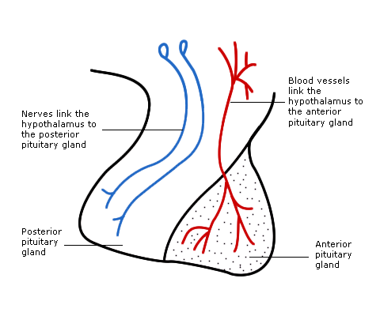

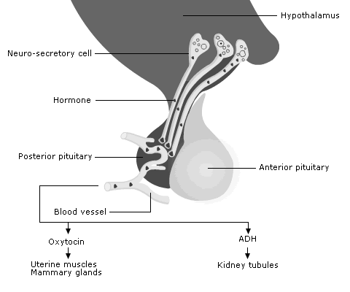

**How are the hormones regulated?**

negative and positive feed-back via the Hypothalamic-Pituitary -Axis.

**Negative feedback**

One hormone (trophic) may control the release of a second. Once appropriate activity of the second is attained it feeds back to inhibit release of the first.

For example- TSH-> TSH-> THYROID->T3/T4

**Positive feedback**

Positive feedback may also occur but is less common. This occurs where secretion of a hormone is enhanced by an increase in the substrate targeted.

For example- effect of oxytocin on lactation

**Tell me about ADH?**

(aka Vasopressin)

* Synthesized principally in supra optic hypothalamic nuclei
* Released from axon terminals in posterior pituitary
* Small molecule of nine peptides only
* Originally a 166 amino acid molecule
* Released by neuronal depolarization in response to rise in plasma osmolality, mainly by increased sodium concentration
* Suppressed by ingestion of water and fall in plasma osmolality
* 1-2% sensitive to change in Na+ concentration
* Short half life: t1/2 (<5 min), unbound
* Increases the water permeability of distal convoluted tubule and collecting duct through increased transcription and insertion of water channels ([Aquaporin-2](https://en.wikipedia.org/wiki/Aquaporin))

Additional factors that stimulate ADH release include

* Fall in blood pressure (10% sensitivity)
* Fall in blood volume
* Fall in cardiac output
* Standing
* Intermittent positive pressure ventilation
* Physiological stress
* Nausea and vomiting
* Various drugs (some tricyclics, analgesics, anti-epileptics etc.)
* Angiotensin II
* Nicotine
* **What is effect of lack of ADH?**

Diabetes Insipidus: [hypernatremia](https://en.wikipedia.org/wiki/Hypernatremia), [polyuria](https://en.wikipedia.org/wiki/Polyuria), and [polydipsia](https://en.wikipedia.org/wiki/Polydipsia).

**Types of DI?**

Neurogenic and nephrogenic DI

**Differentiate btw neurogenic vs nephrogenic DI?**

neurogenic - Decreased ADH release

nephrogenic- decreased renal sensitivity to ADH by mutation of V2 receptor or Aquaporin

**Tell me about ACTH?**

Released From Ant. Pituitary

39 Amino Acid polypeptide hormone

Stimulates release of Corticosteroids from the adrenal glands.

ACTH release is dependent on Corticotrophin Releasing Hormone (CRH) from the Hypothalamus.

**Describe the pathway of steroid synthesis in the Adrenal Cortex?**